Springs That Form Headwaters of San Antonio River Protected Forever
Brendan Gibbons
July 28, 2020
The springs that form the headwaters of the San Antonio river will be forever protected from development, thanks to an agreement involving the Sisters of Charity of the Incarnate Word and Green Spaces Alliance.
On Friday, leaders of the Headwaters Preserve at Incarnate Word told the Rivard Report they had placed the 53-acre preserve north of downtown under a conservation easement. A conservation easement is a restrictive covenant that permanently bars construction, paving over natural surfaces, mining, or drilling on the land.
“The little efforts, the local efforts, make a difference,” Sister Teresa Maya, the order’s congregational leader, told the Rivard Report. “We can’t go to the Amazon to save the rainforest there, but we are really responsible for making sure that what we have is preserved for the future.”
Originally part of the 280 acres the Incarnate Word sisters purchased in 1897 from banker George Brackenridge, the property is a formative space for the Catholic order. The nuns established their mother house on the former Brackenridge land, then moved their Academy of the Incarnate Word to the site from its former location in Government Hill. That school eventually became the University of the Incarnate Word.
The Headwaters nonprofit now manages the remaining 53 acres, safeguarding the space and holding regular educational and spiritual events. Dozens of volunteers meet there regularly to cut down invasive trees and build trails on the property, among other improvement.by Brendan Gibbons
“It’s a growing community, all kinds of people, young and old,” Maya said. “Birdwatchers, wildflower lovers, and Ligustrum pullers. That, to me, has been the gift – to see that community grow.”
T. Weir Labatt, III, chair of the Headwaters nonprofit, said it has been “amazing” to meet people at the preserve over the years who would ask him how close the nonprofit was to signing a conservation easement, a relatively obscure type of agreement.
“They knew it had been talked about and in progress for a good, long time,” Labatt said. “That was a pretty predominant question that would be asked.”
The preserve is also home to the Blue Hole, the largest of the artesian springs on the property that form the headwaters of the San Antonio River. During rainy periods, clear water rises up from the Edwards Aquifer and fills a stone well built around the spring.
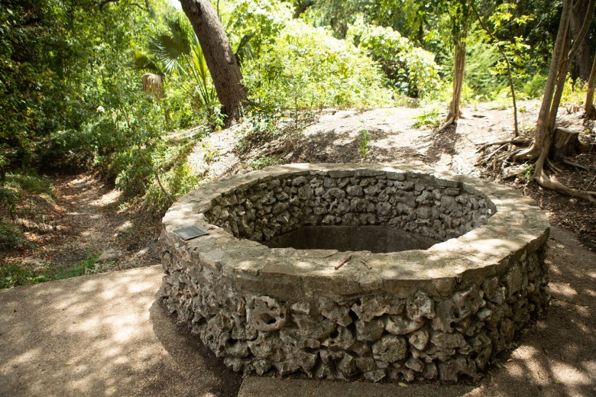The Blue Hole is the largest of the artesian springs on the property that form the headwaters of the San Antonio River. Credit: Bonnie Arbittier / Rivard Report
This reliable source of water drew indigenous people to the site for thousands of years before European contact, past archaeological studies indicate. Reports of the spring by 1800s-era visitors described it as a gushing fountain sometimes rising up to 20 feet in the air.
Pumping of the Edwards Aquifer over the last 130 years has reduced the artesian pressure on the water flowing out of the spring. Now, water simply flows out of the spring when the water table in the aquifer below San Antonio reaches around 676 feet above mean sea level.
The site is open daily from dawn to dusk to visitors on foot and those with leashed pets. Because of the coronavirus outbreak, visitors must clear a UIW screening checkpoint to access the site and wear a mask while crossing the campus.
As the holder of the conservation easement, the nonprofit Green Spaces Alliance’s job is to ensure that the property perpetually meets the requirements listed in the easement. For example, one provision limits the amount of hard surface on the land, such as asphalt, concrete, or rooftop, to 2 percent, or 1 acre, Green Spaces Director Doug Dillow said.
“It still does allow for the Headwaters organization to build trails and allow for public use and access,” Dillow said.
The signing of the easement marks a milestone in the eventual extension of the pedestrian and bike trails along the San Antonio River north to the Blue Hole. Many call the proposed extension the Spirit Reach, a nod to the sacredness of the spot to native people and modern-day residents.
“I think it’s just fabulous,” Suzanne Scott, general manager of the San Antonio River Authority, said of the easement signing. “I’m glad they were able to make it work. I think the right people were in the right place at the right time to get that done.”
For now, plans to extend the San Antonio River trail under Hildebrand Avenue and connect to the Blue Hole are mostly in the idea phase although a proposal was underway to commit $10 million in Bexar County funding for the Spirit Reach before the coronavirus outbreak took hold in March. That has since been stalled as the pandemic ravages local government budgets.
“There’s energy and excitement behind it,” Scott said. “It’s just that everything was put on pause.”

