‘God is not making more Honey Creeks’: Longtime neighbors clash over planned Hill Country development
Joyce Moore lives in Gillespie County, but on many weekends, she makes the roughly hourlong drive south to Bulverde to the 640-acre ranch where she grew up, land that has been in her family for nearly 150 years.
Last Saturday, termite damage was the issue of the day. She and her 19-year-old son Josh worked in 103-degree heat fixing a decaying roof on a century-old pumphouse. After long days such as this, Moore likes to drive up to the old chapel on the hillside, where she can see across the rolling hills of oak, juniper, prickly pear, and native grasses.
“I used to enjoy coming out here,” Moore said. “Now, I don’t, and I can’t with what’s to come.”
Moore now only sees what will soon change that view forever. A massive residential subdivision planned by her neighbor to the south originally called for 2,400 homes packed on small lots. Ronnie Urbanczyk and his wife, Terry, own approximately 560 acres and have lived in the area 6 miles northwest of Bulverde on State Highway 46 since the early 1990s.
Moore remembers when she first heard about the Urbanczyk development from one of the hunters to whom she leases her land. “I felt sick to my stomach,” she said.
That’s because the original plans for the development called for discharging up to 500,000 gallons per day of treated wastewater into Honey Creek, which starts on Urbanczyks’ property. The creek is typically dry until it reaches the eastern and southeastern part of Moore’s land, where it suddenly springs to life.
Fed by water pouring out of Honey Creek Cave, the stream forms a series of pools and riffles, shaded by towering cypress and sycamore trees. Bass, sunfish, and other native fish dart beneath the lily pads dotting the surface of the clear water. Biologists consider the creek one of the most pristine examples left in the region of what Hill Country creeks looked like before European settlement.
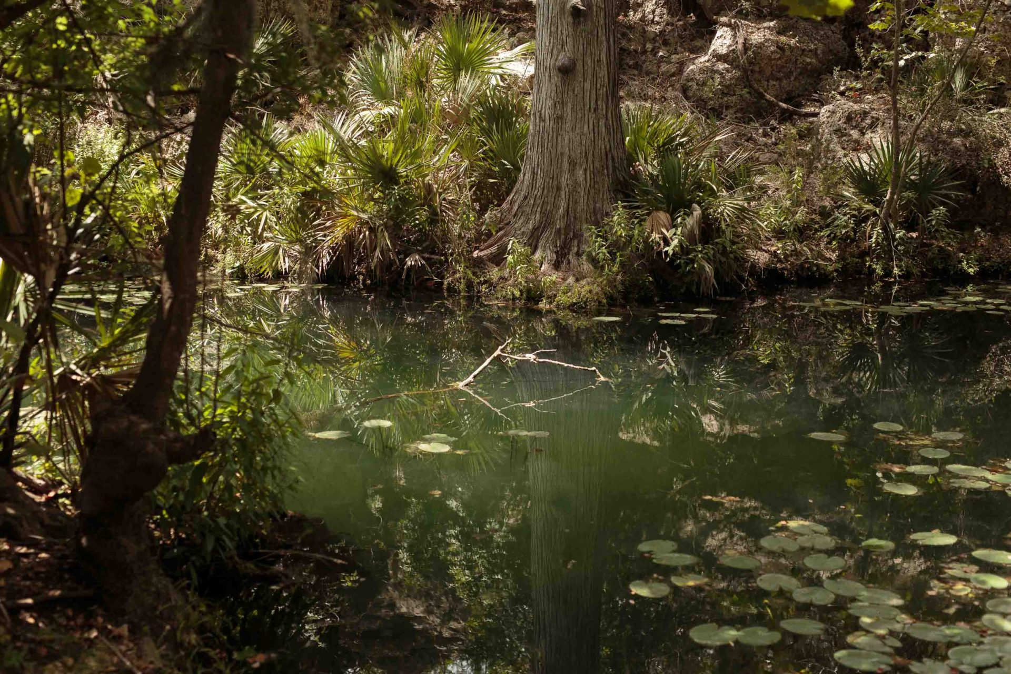

The water that feeds Honey Creek stays at a constant temperature in the low 70s.

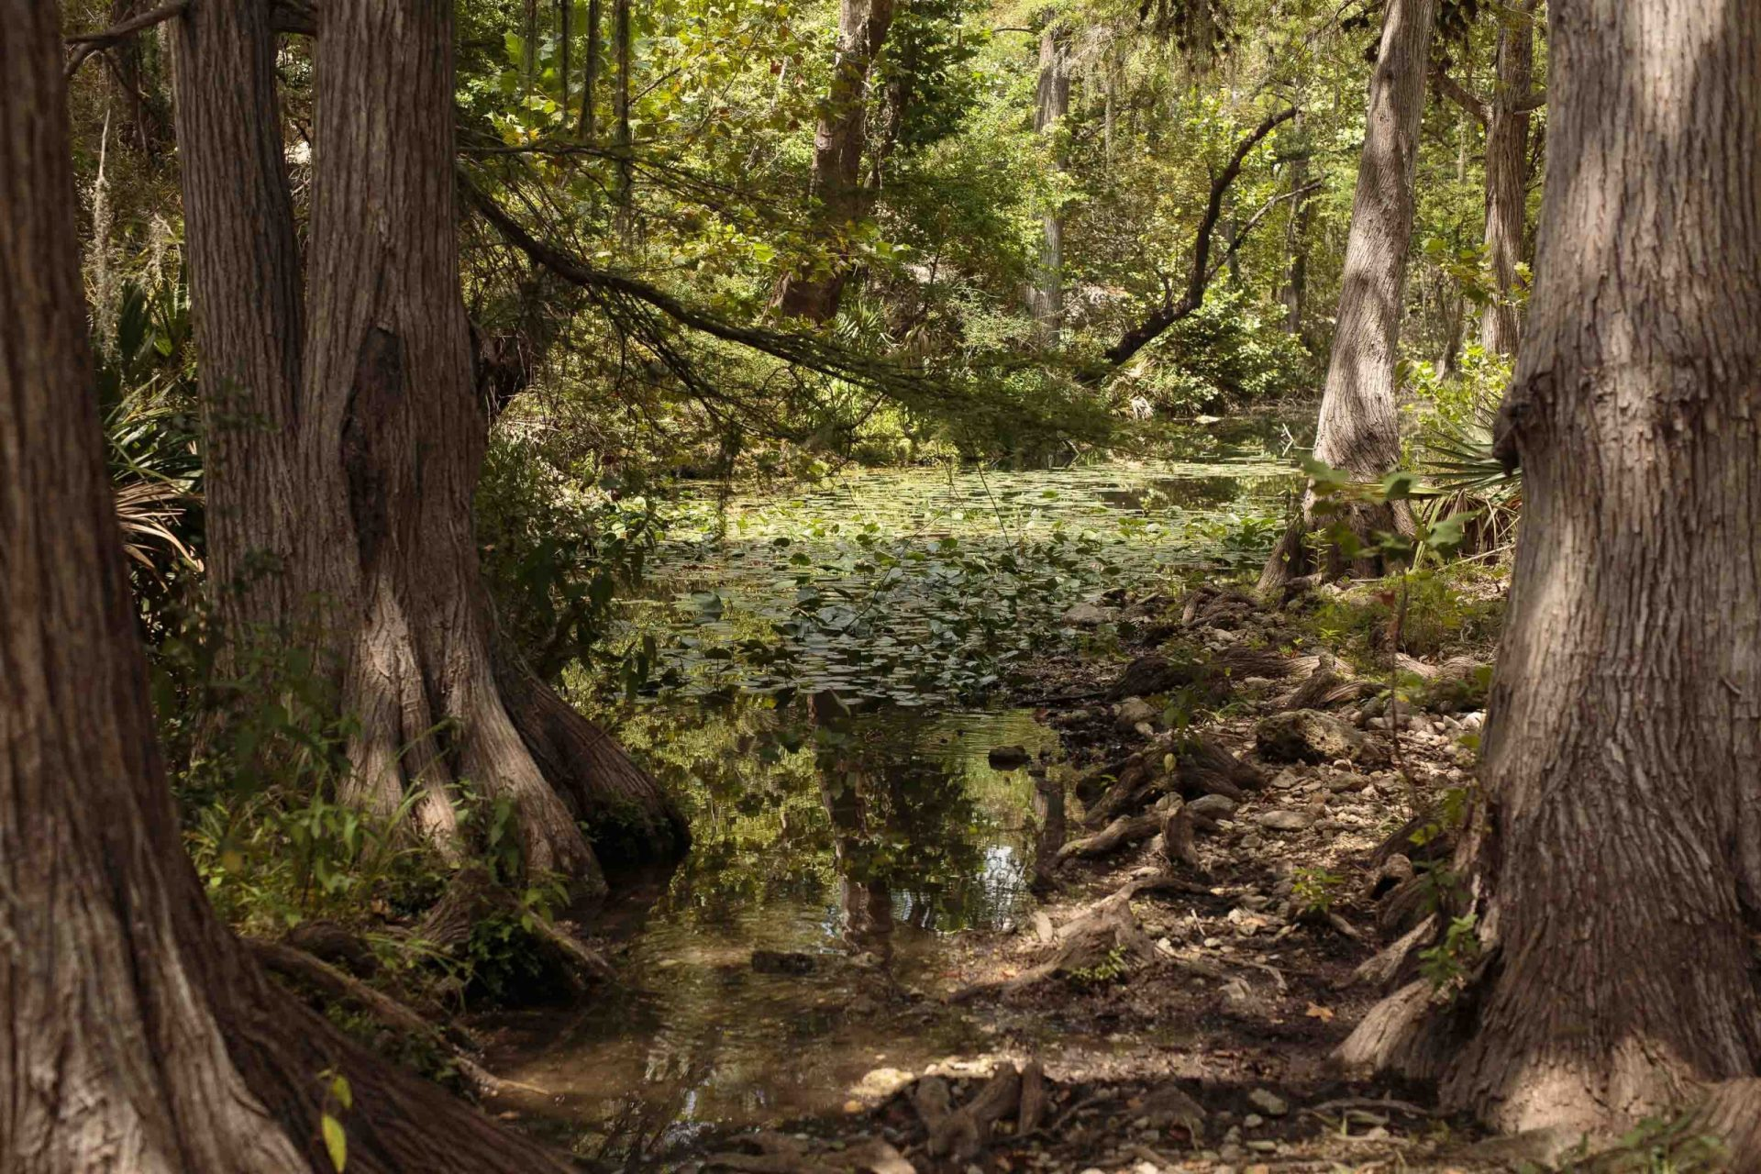

Honey Creek is a nearly untouched water source on private property near Guadalupe State Park.

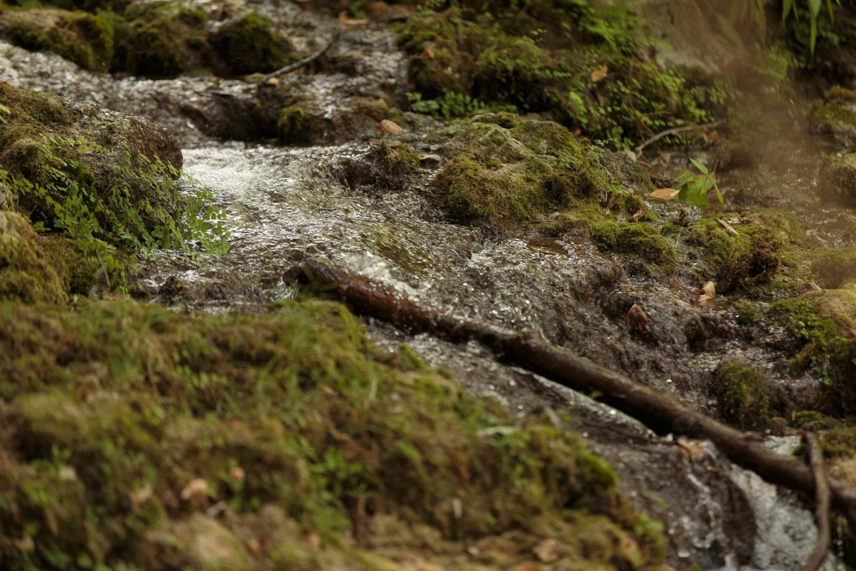

A trickling stream flows into Honey Creek from the cave outlet.

Development was probably inevitable for this area on the northern fringes of the San Antonio metropolitan area. In recent years, the U.S. Census Bureau has listed Comal County as among the fastest-growing in the nation. The cutting up of large ranches into 5-acre ranchettes and dense subdivisions like Ventana, built across State Highway 46 from the Urbanczyk ranch, is driving up land prices. Everyone wants their own little slice of the Hill Country.
But to some longtime landowners like Moore, the rampant development is a “cancer” that sucks dry sensitive aquifers and fills creeks with algae-growing wastewater from sewage treatment plants. “I don’t know where they’re all coming from, but somebody has to stop this,” she said of the new subdivisions and strip malls. “I feel like it’s a train and I can’t get out of the way.”

Environmental details adjusted
Conservationists saw the threat of unbridled development in the Hill Country as early as the 1980s, when the Texas chapter of The Nature Conservancy and other groups worked to preserve what is now Honey Creek State Natural Area, just downstream from Moore’s ranch. It eventually was signed over to the Texas Parks and Wildlife Department (TPWD).
Following a public outcry over the development plans and intense negotiations with the TPWD and the Texas Commission on Environmental Quality (TCEQ), Urbanczyk withdrew the application in late 2019 for a discharge permit and applied for a permit that would allow 365,000 gallons per day to be discharged onto 84 acres of common area on the site via an underground drip irrigation system. No longer is the plan to discharge directly to Honey Creek.
That permit is now under review by the TCEQ, the state’s environmental regulator. If it grants the permit, the TCEQ will remove one of the final hurdles standing in the way of construction, though Urbanczyk must still submit development plans and engineering documents to the City of Bulverde. It’s not clear when the TCEQ will decide on the permit; the issue is not listed on its draft agenda for commissioners’ Sept. 9 meeting. Commissioners could also funnel the permit through a months-long contested case hearing, which would delay a final decision.
New designs for the development, on property now called Honey Creek Ranch, have drastically reduced the subdivision’s density, down from the original 2,400 homes to around 1,700, said David Holmes, a friend of Urbanczyk’s who’s working with him as a consultant on the project. But he called that number “flexible.”
“If I look at that old development plan and I look at the plan that’s on the table now, they are tremendously different,” said Holmes. “Not only in terms of density, in terms of the attention paid to environmental details.”
Those assurances don’t make Moore feel any better. All the drip irrigation system will do is “mainline” the treated wastewater into the many conduits in the shallow limestone, where it will inevitably make its way into Honey Creek Cave, she said. Moore’s land includes the entrance to the cave, the longest known cavern in Texas, with 20 miles of explored passageway.

MORE ON HONEY CREEK
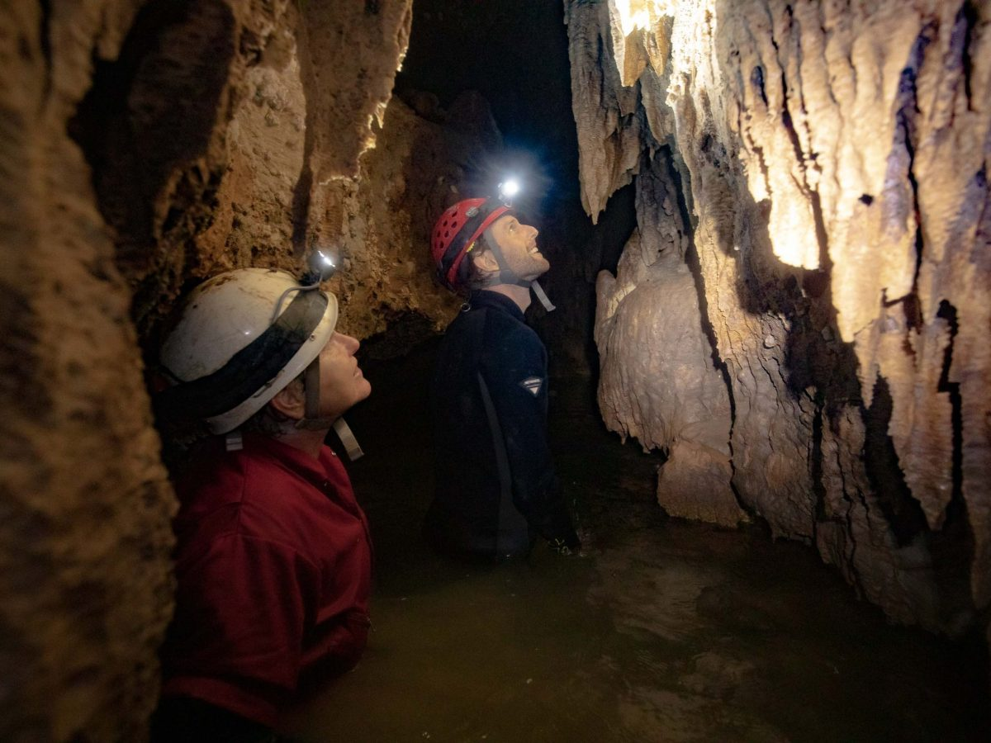

A trip inside Honey Creek Cave, the longest in Texas
y Brendan Gibbons
The development’s potential effect on the cave and creek is a little more complicated than that, according to George Veni, director of the National Cave and Karst Research Institute. A San Antonio native who now lives in Carlsbad, New Mexico, Veni did his doctoral dissertation on Honey Creek Cave and the complex network of underground water pathways in the area. He’s been exploring the cave since the 1970s and has taken dozens of geology students on trips there to observe the way water moves underground.
The effluent from the development probably won’t make its way to the explored part of the cave, Veni said, but will enter an unexplored part that extends under the Urbanczyks’ property. His research shows it will flow toward Cibolo Creek and then into the Edwards Aquifer. He described the flow path as a “finger” of recharge to the aquifer. The effluent could potentially affect water quality for nearby groundwater well users who happen to tap into that finger of recharge.
Veni said the more serious problem for Honey Creek is likely the runoff from the development. Heavy rains could send fertilizers, herbicides, motor oil, detergents, trash, personal care products, and pharmaceuticals down Honey Creek. He sees it as the inevitable degrading of the creek.
Holmes said the plan is for Honey Creek Ranch to implement restrictions on each homeowner that could limit the use of chemicals like fertilizers and herbicides. He declined to share a draft of those rules, saying it’s “rough and not ready for prime time.”
“We have not gotten to a point of maturity in this project where we can implement that,” Holmes said, adding that those restrictions “typically come much later in the development.”

‘It’s either I do it, or they do it’
For Urbanczyk, the public unveiling of his new development had gotten off on the wrong foot from the beginning. First, there was the widespread dissemination of the early version of his development plans. It didn’t help that for months the public face of the project was wastewater consultant Kelly Leach, who tended to offer gruff, one-word answers to basic questions about the development.
To show the changes made to the plans since the initial version, Urbanczyk and Holmes met with journalists at the Urbanczyk ranch recently.
The two sat at an interior table in a wood-paneled trophy room in a high-ceilinged building set among a cluster of old ranch buildings. One dated back to the 1800s, relocated by Urbanczyk from elsewhere on the ranch to save it from flooding, Holmes said. A chicken coop sat across the road. The blade of a windmill rotated in the late morning breeze.
At the top of the hill stood the original ranch house, which was there when the Urbanczyks bought the property.
Urbanczyk and Holmes sat across the table, multicolored renderings of the development spread in front of them, showing newly drawn green spaces and amenities. Holmes, formerly CEO of Santikos Entertainment and senior vice president of sales and underwriting at insurance company USAA, described changes to the design.
The Urbanczyks donated 5 acres off Highway 46 for use as an EMS substation and 150 acres for an elementary, middle, and high school to Comal Independent School District at a “favorable” price for the district, Holmes said.
Urbanczyk also is agreeing to multiple regulations that state and local laws don’t require for the development, including cooperating with dark-sky standards meant to prevent light pollution in the area. After pressure from the TPWD and TCEQ, they’ve agreed to treat the discharge water to levels clean enough to swim in, even though regulations don’t require it.
Like Moore, Urbanczyk couldn’t help but feel the pressure of the suburban sprawl closing in on him. Several years ago, another neighbor put around 250 acres up for sale, telling Urbanczyk that home builders were interested in the land. Urbanczyk bought it from him two weeks later. To him, it was an acknowledgment that change is coming; better to control it than let it control you.
“It’s either I do it, or they do it,” Urbanczyk told his wife. “If they do it, I’ve got to live with it.”
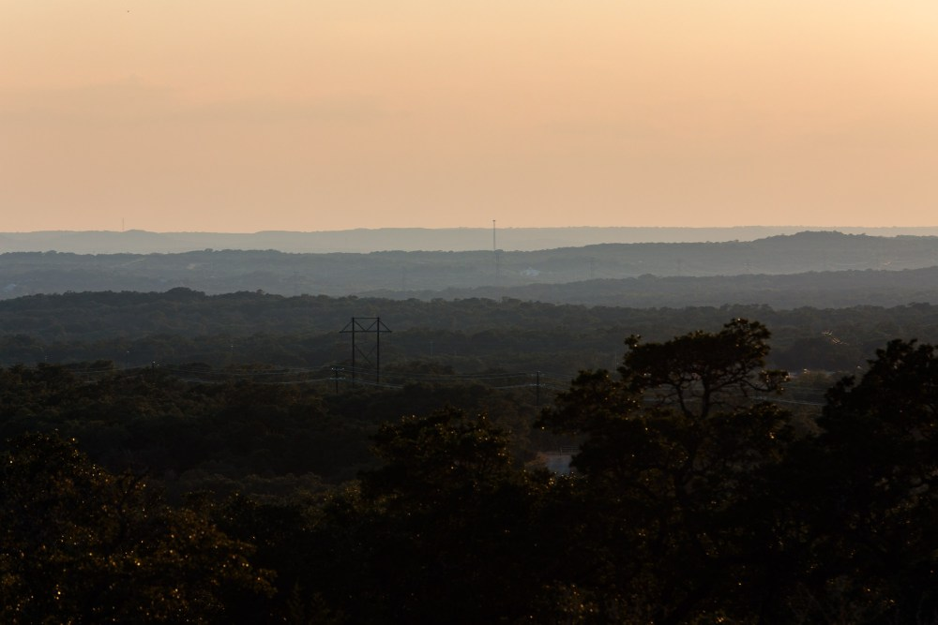The two ranches owned by Ronnie Urbanczyk and Joyce Moore stretch across the rolling hills of the Texas Hill Country and Guadalupe State Park. Credit: Scott Ball / San Antonio Report
In Urbanczyk’s mind, a series of disparate events illustrates the inevitability of growth encroaching on longtime ranchlands.
He used to have exotic wildlife on the property. That is, until a neighbor’s dog jumped his fence and killed an African antelope that cost at least $20,000.
“I called the sheriff,” Urbanczyk said. “He said, ‘Yeah, that’s pretty bad.’ I said, ‘What do I do?’ He said, ‘That dog’s got more rights than you do. You shoot that dog, you’ll be in jail.’ So then we got rid of all the animals.”
One day, an 18-wheeler clipped his daughter’s car on Highway 46 when she was entering the ranch. It took off part of the vehicle, but she was unharmed.
Then came the Ventana subdivision. An unsightly storage unit business directly across the street followed. Urbanczyk decided it was time to do something.
The idea for his own development came when Urbanczyk’s son, whom he calls “little Ronnie,” was looking to buy a home in the Bulverde area. He couldn’t find one he could afford, so he ended up buying a DR Horton home on San Antonio’s far West Side for $185,000.
That bothered Urbanczyk. He started talking to some of the business leaders and local officials in the area. He realized how difficult it is for working-class people to buy property in Bulverde.
Homeownership is a big deal for Urbanczyk, who always told his three kids, “if you can pay your house off, and all you have to pay is groceries and utility bills, you can dig a ditch or whatever you need to buy groceries and pay the bills.”
Urbanczyk grew up on San Antonio’s South Side with an electrician father and a mother who worked for his father’s business. His family owned a small farm, and Urbanczyk always enjoyed building, growing crops, and raising cattle. He’s been in the concrete business since the 1970s, but he’s also active in the San Antonio Stock Show & Rodeo and is a major supporter of local Future Farmers of America programs.
“I love kids that go through college, but there are just a lot of kids that can’t go through college that, like me, have no desire to go to college,” Urbanczyk said. “My passion is helping kids like them out and showing them that if you work your ass off, you’re gonna do good, you’ll make a good living. There’s always a job for a hard-working guy.”
Urbanczyk looks at his soon-to-be-developed ranchland and sees 1,700 new houses that will soon be home to people who can afford a $250,000 to $350,000 home.
“If you’ve got the land and it’s available, and you can do better things with it, then you should,” Urbanczyk said, adding that he’s doing it in a way that avoids damage to the creek.
Ronnie Urbanczyk looks over plans to develop his Honey Creek Ranch, located along Highway 46 west of Bulverde, into a residential neighborhood with roughly 1,700 homes priced between $250,000 and $350,000. Credit: Scott Ball / San Antonio Report

Generations of stewardship
Even though the Urbanczyks have been there 30 years, to Moore, her neighbors are “newcomers.” In the Hill Country, long-established families often use the word to describe neighbors who have not lived there for generations. She remembers when they first moved to the area.
“I remember when they bought it and they put that big ol’ gate up there and it said Honey Creek Ranch,” Moore said, something that made her family chuckle.
That’s because if any ranch deserved to be called Honey Creek Ranch, it was Moore’s. Her ancestors are the ones who named the creek in the first place. Family lore has it that before the settlers could dig a well in the area, the creek was their only water source. A young boy sent down to fetch water had headed back home empty-handed, deterred by swarming bees. They figured there must be honey down there, too.
Moore spent her early life on the ranch and now has a career helping other Texas landowners manage their natural resources. The property has been passed down on her mother’s side, descendants of German immigrants George Friedrich and Christina Bechtold Kunz, who came with the wave of immigrants following Prince Carl of Solms-Braunfels in the 1840s.
Unlike many German Catholic families, Moore’s was small. She credits the lack of squabbling siblings as one reason the land has been kept intact for so long. Before Moore’s parents died, they set up a family trust, leaving the land to Moore and her sister, who lives in San Antonio. Neither can make any decisions about the fate of the place without consensus from the other. Moore intends to continue that structure when the ranch passes to her son and his only cousin.
Moore sees her ownership of the property as a duty of stewardship. She has a legacy to maintain. Plus, she believes in the “land ethic,” a phrase coined by environmentalist Aldo Leopold to describe a sense of moral right and wrong over how people treat the natural world.
“I’m just a caretaker,” Moore said. “I’m just here for a little while.”
In 30 years of owning large ranches next to each other, Urbanczyk and Moore remain basically strangers. They’ve never spoken to each other, Moore said, and she feels he doesn’t have the same connection to the land that she does.
“To him, it was just a spot on a map, it didn’t mean anything,” Moore said of Urbanczyk. “To me, it means a lot.”
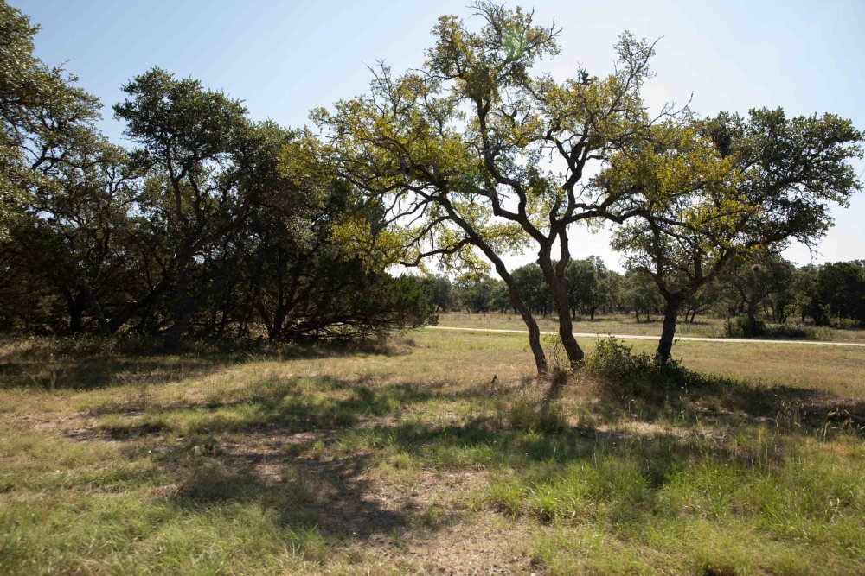The Honey Creek Ranch owned by Ronnie Urbanczyk is in the planning stages of being developed into a dense neighborhood just miles from Guadalupe State Park. Credit: Scott Ball / San Antonio Report
During an interview at a coffee shop in Boerne this month, Moore was nervous about sharing her feelings about the whole situation, fearing some kind of reprisal from Urbanczyk.
On one central point, she didn’t hold back.
“You come into an area you don’t know. You buy it as an investment and you don’t even attempt to meet or get along with your neighbors. You devalue their land. You contaminate their water supply,” she said. “What am I supposed to think about these people?”
Until learning about it from a reporter, Moore didn’t know a high school would be built near her property entrance on Park Road 31. That’ll only worsen the problems she has with trespassers trying to explore the cave and Honey Creek, she said.
Despite the motion-activated game cameras installed around the cave entrance and other efforts to protect the site, she can’t put the place under armed guard 24/7. Her family’s watchful eye has kept the creek pristine all these years, but continuing to do so will be nearly impossible with an influx of new residents, she said.
Back in the 1980s, the Texas Parks and Wildlife magazine featured a cover photo of the cave entrance. That led amateur explorers, magazine in hand, to the site. Her dad “came unglued,” she said.
“The public will love things to death, and you can look at any of our national parks and see that,” she said.
After all those years of stewardship, all the efforts to protect something that means so much to her, Moore feels like she’s running out of options to keep Honey Creek’s water pristine and its ecosystem thriving.
That’s an ecosystem Urbanczyk has never seen. During the interview at his ranch, he said he had never stood alongside the creek at the state natural area. He did, however, help build some of the trails, the parking lot, and the equestrian area, he said. He hasn’t been inside the cave, either.
Surprisingly, neither has Moore. She can’t swim, so she’s only seen its treasures in pictures and video. She says she doesn’t need to experience the cave firsthand to care about protecting it.
“God is not making any more Honey Creeks,” Moore said. “There are no more being created, last time I checked. So to me, we have to steward what we are given, and what they’re trying to do is not stewardship.”
If all goes according to plan, Urbanczyk could see the bulldozers and other heavy equipment and an army of workers come onto his land sometime next year. He and Moore could have new neighbors not long afterwards.

